- Health and defence are the two big winners in the UK spending review delivered today. Outside of these departments, we estimate the average annual real terms spending increase is just 0.4% a year.
- Considering the plans require large efficiency savings, departments may find it hard to stick to the targets. What's more, the government has offered no guidance on how it would adapt its spending plans if – as expected – NATO significantly raises its target for defence spending.
- Like the Spring Statement, today's spending review leaves the impression of being a stopgap, rather than a durable plan.
- The Office for Budget Responsibility is likely to make unfavourable revisions to its economic and fiscal forecasts in the autumn. And considering the government's recent U-turn on winter fuel payments could be a precursor to higher government spending in other areas, it looks increasingly likely that substantial tax increases will be needed in the autumn Budget.
UK Chancellor Rachel Reeves presented her spending review today, setting out departmental day-to-day spending plans through to 2028-2029, with plans for capital spending running for an extra year. The spending totals were very similar to those included in the Spring Statement, so today's announcement doesn't imply any change to the UK fiscal position. And as the spending totals are already incorporated in our economic forecasts, today's announcements do not change our assessment of the economic outlook.
On average, total spending (day-to-day spending plus investment) will rise by 1.5% a year in real terms between fiscal year 2025-2026 and 2028-2029. The two relative winners from the spending review were the National Health Service and defence. Elsewhere, the settlements are very tight – we calculate that the average real terms increase for all other departments is just 0.4% a year, with many departments set to endure real terms cuts to their budgets (Chart 1).
Chart 1: Most government departments have been awarded very challenging settlements
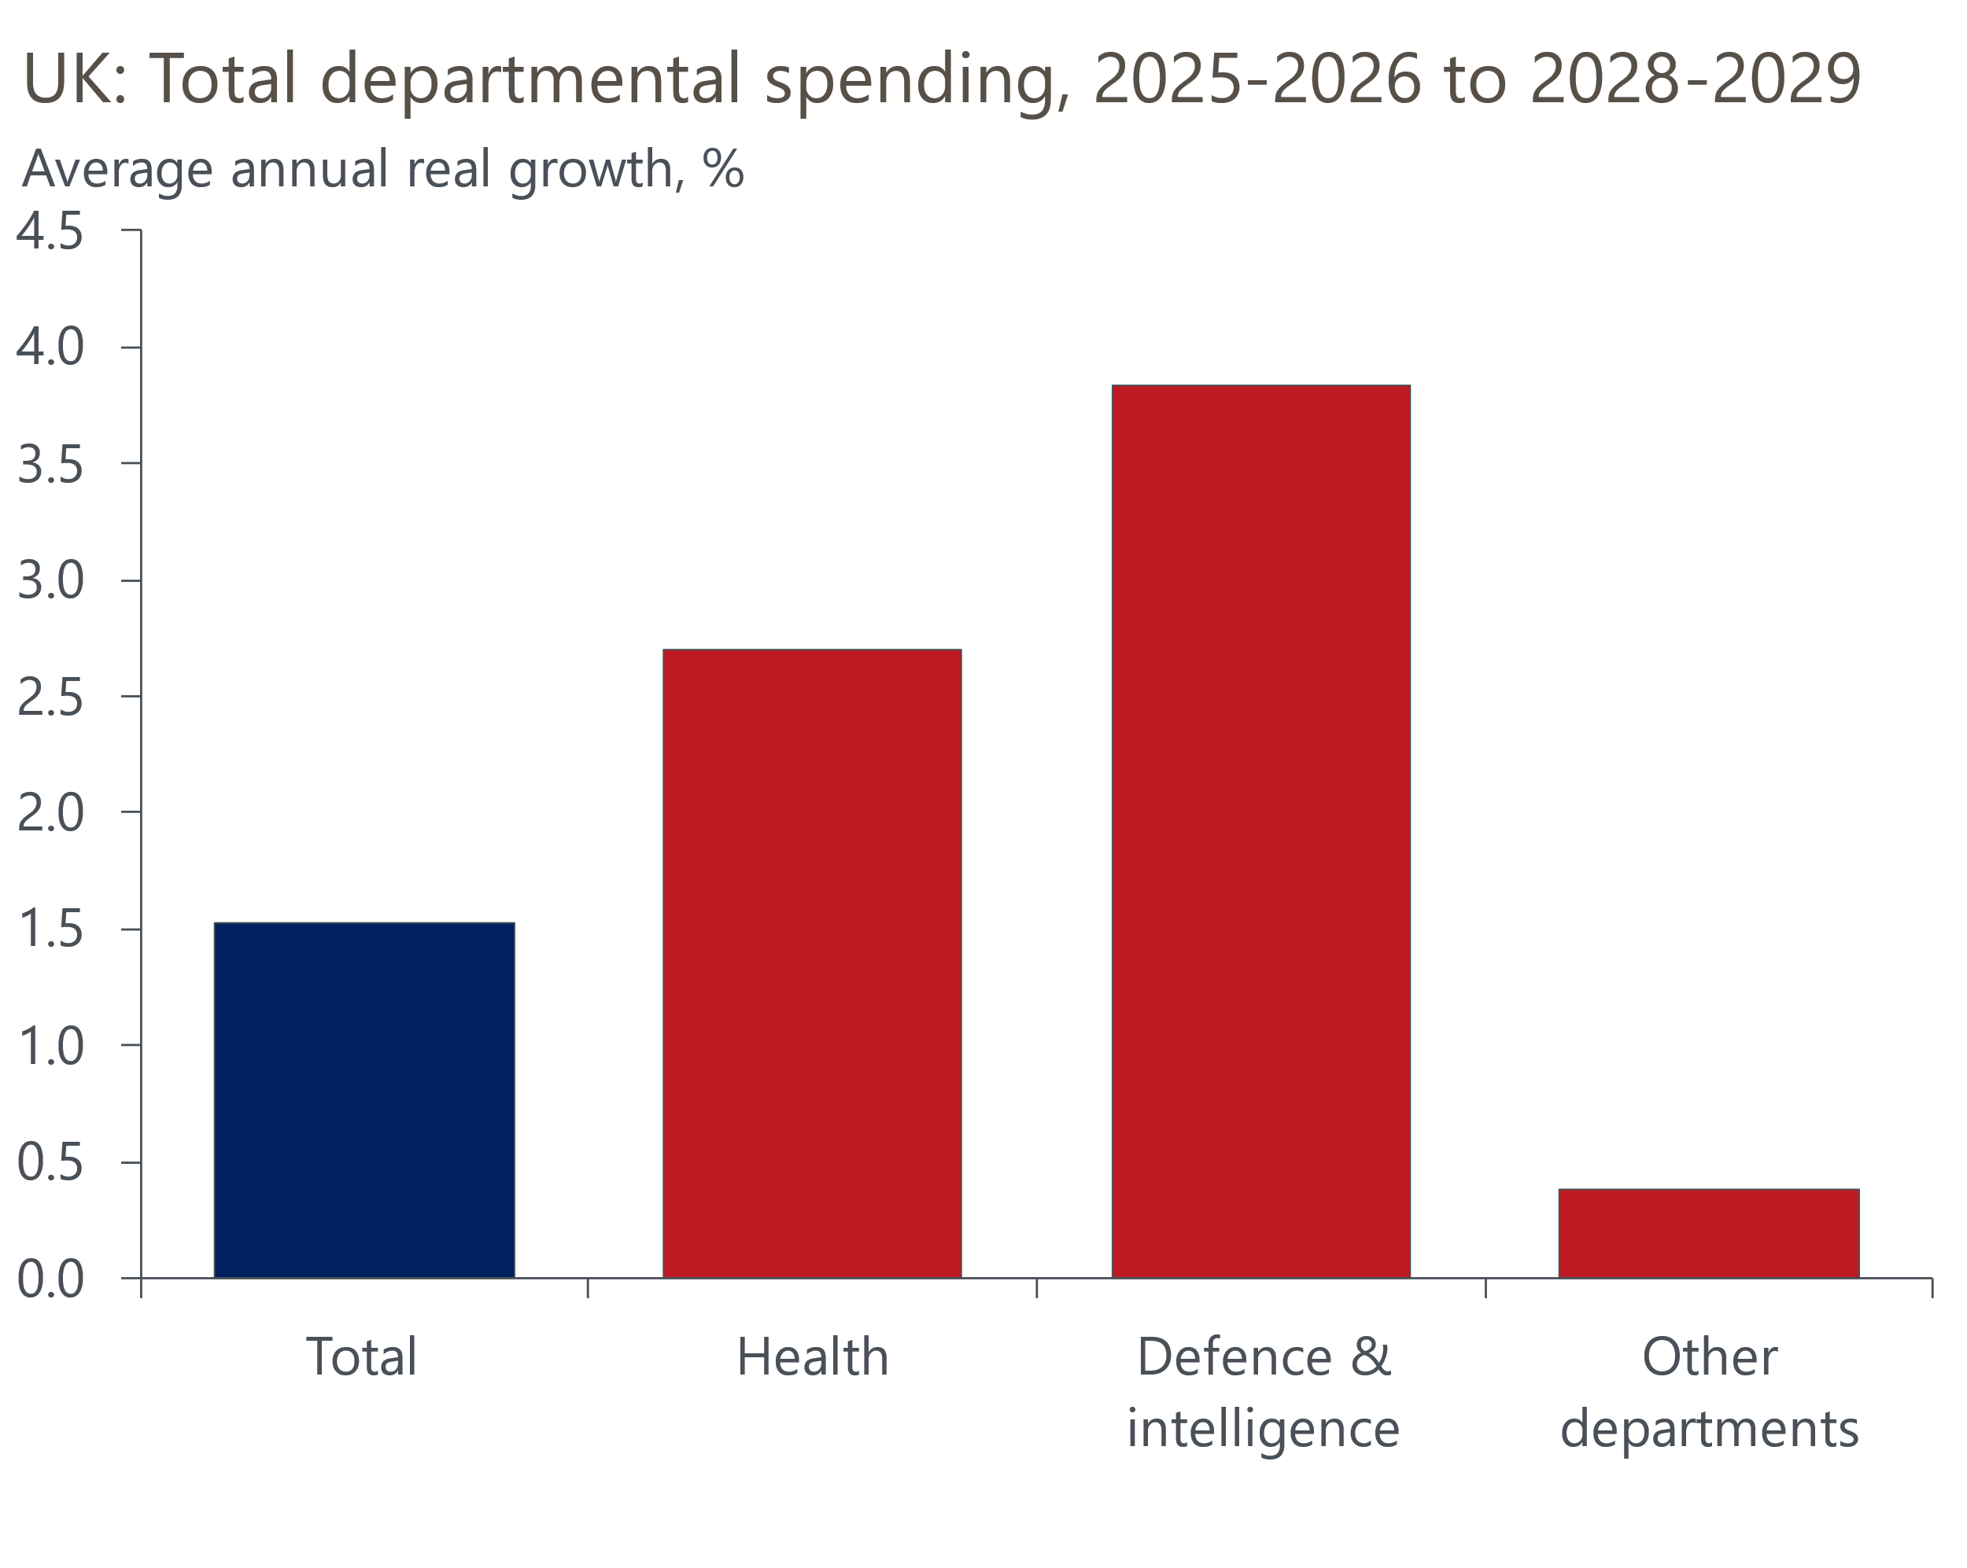
Source: Oxford Economics calculations using data from HM Treasury

The Chancellor has left a reserve of 1% of GDP in the final year, which is similar to the review in 2010 led by former Chancellor George Osborne but much lower than the past couple of spending rounds. The new plans also assume that departments will make £14bn (4% of total spending) a year worth of efficiency savings by 2028-2029. This looks very ambitious and suggests departments may struggle to stick to the plans.
The capital spending allocations focus on defence, transport, and green energy. The increase in spending on improving the UK's crumbling infrastructure is a positive for the economy. But as we argued in our plan for growth, increasing government investment is only one piece of the jigsaw when it comes to improving the UK's long-running poor growth performance. There is still a lot to be done to ease the constraints on private investment. What's more, much of the positive impact of higher investment on the supply side of the economy typically only emerges over a 10–20-year timeframe.
Just as the spring statement was a stopgap, elements of the spending review look likely to have a similarly short shelf-life. The Chancellor confirmed an increase defence spending, which will reach 2.6% of GDP in 2027. But there was no guidance about how the government would respond if NATO sets a much higher target, as seems likely to be announced at the summit later this month. NATO Secretary General Mark Rutte recently suggested the new target could be 5% of GDP, with 3.5% of GDP being direct defence spending. As our recent report explained, achieving a higher NATO target would be very costly and it seems implausible that spending could be held at 2.6% throughout this parliament and then suddenly ramp up in the next one. Some of the extra spending would need to happen sooner.
The government has also said it will reinstate winter fuel payments to many pensioners this year, while calls from some MPs to end the two-child benefit cap are becoming more strident. So government spending plans are likely to be higher outside of department budgets.
In addition, it's highly likely that the Office for Budget Responsibility will make unfavourable revisions to its economic forecasts. Its potential output forecasts are well above consensus and its forecast evaluation report to be published on July 1 may lay the ground for downward revisions. This would mean lower tax receipts and higher government borrowing. If recent movements in financial market pricing hold, debt servicing costs will be around £2.5bn higher than they were at the time of the Spring Statement. The OBR might also conclude that recent undershoots in tax revenues will prove more persistent.
To make the fiscal position look healthier, the government might decide it has some scope to pencil in additional current spending restraint in 2029-2030 – this is the key year for the fiscal rules and falls outside of the period covered by the detailed department plans. But we think this would risk undermining the government's fiscal credibility, so we still expect the government will need to implement relatively large tax rises in the autumn Budget.

